**Combi – Oven Deliverables**

1. PCB Board Deliverables
   * Main PCB Board.
   * 6 Pin Cable.
   * Power Measurement PCB Board.
   * 3 CT Coils.
   * 10 Nos 12 mm Bolt nut.
2. Flow sensor.

* 1.5 meter 3 core wire

1. Temperature Sensor.
2. Audio Board.
3. Speakers.

* 5 meters of 2 core wires for 2 speakers

1. Android Tablet.

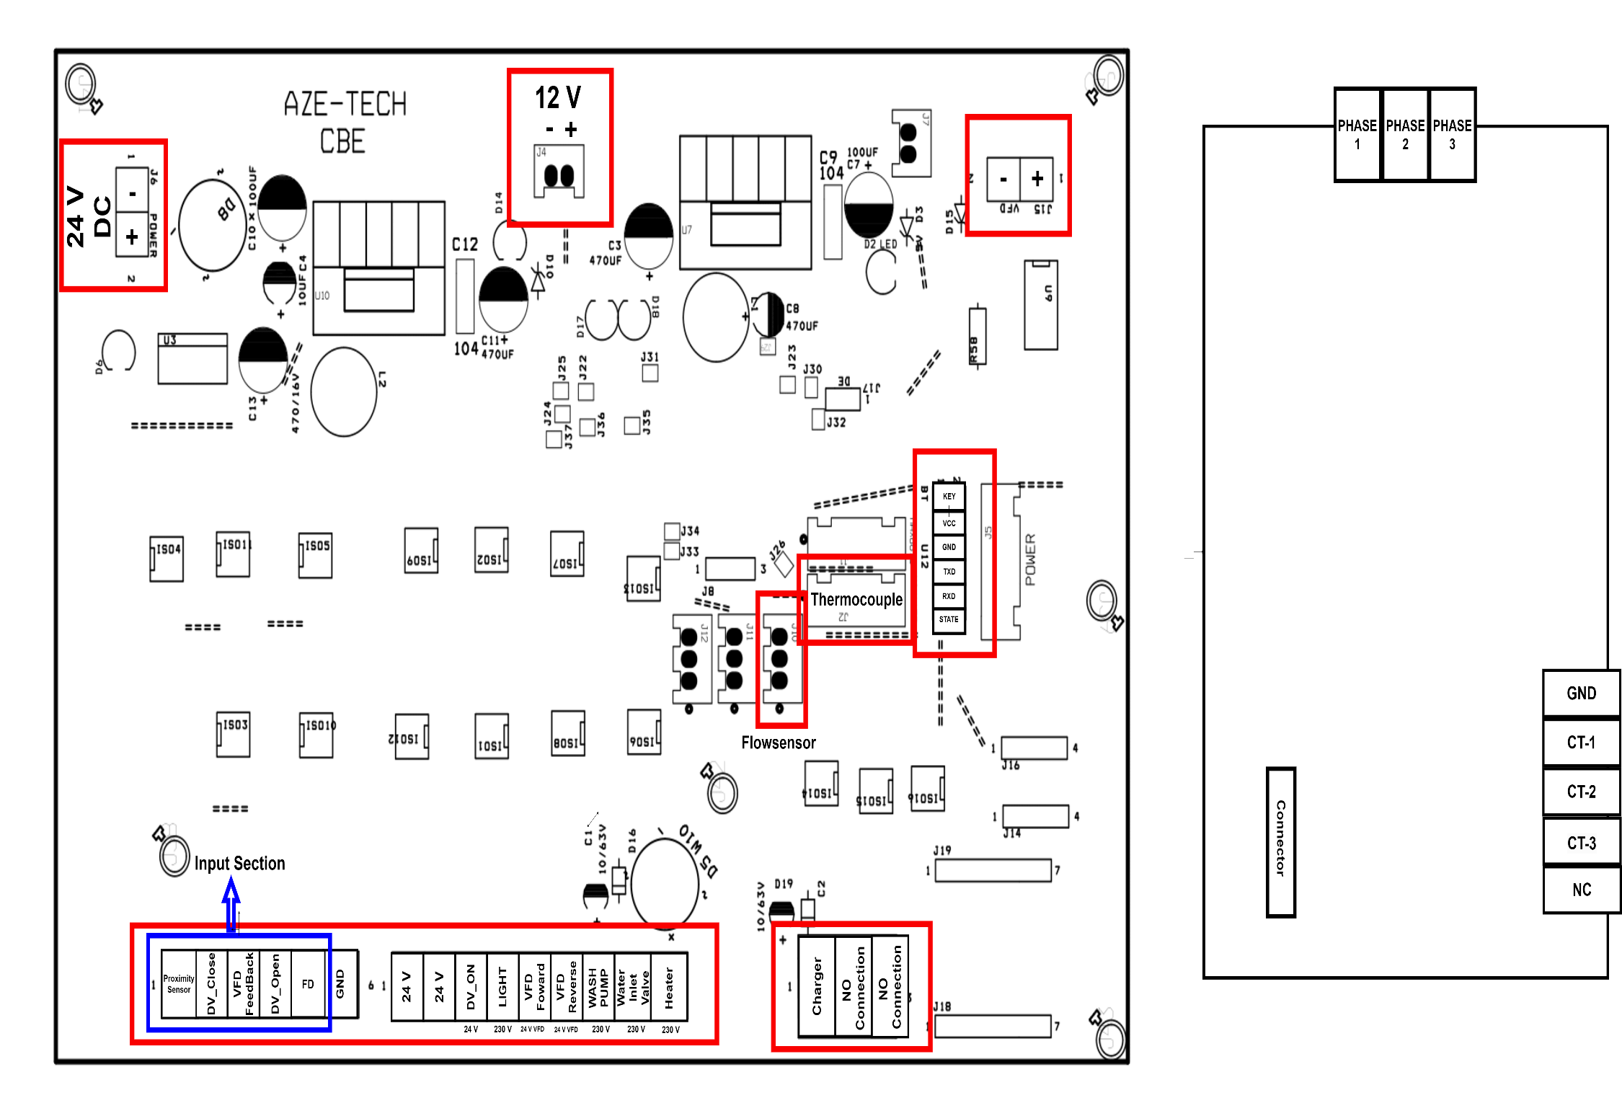

**12**

**13**

**11**

**10**

**9**

**8**

**7**

**6**

**5**

**4**

**3**

**2**

**1**

1. **Input Power supply**

* The 24V SMPS power supply is connected using these two pins.
* An important note is that the SMPS supply should only be connected to the PCB board.
* If any 24V supply is needed, it should be sourced from the PCB board.

1. **12 v Output**

* This Output is used to power the Audio Module

1. **VFD DAC Output**

* A 10V DAC output is obtained from this pin. The voltage of the DAC output is adjusted based on the fan speed value.
* These two pins are connected to the VFD drive.
* The -Ve is connected to the 0V socket as indicated on the VFD.
* The +Ve is connected to the AI1 socket on the VFD.

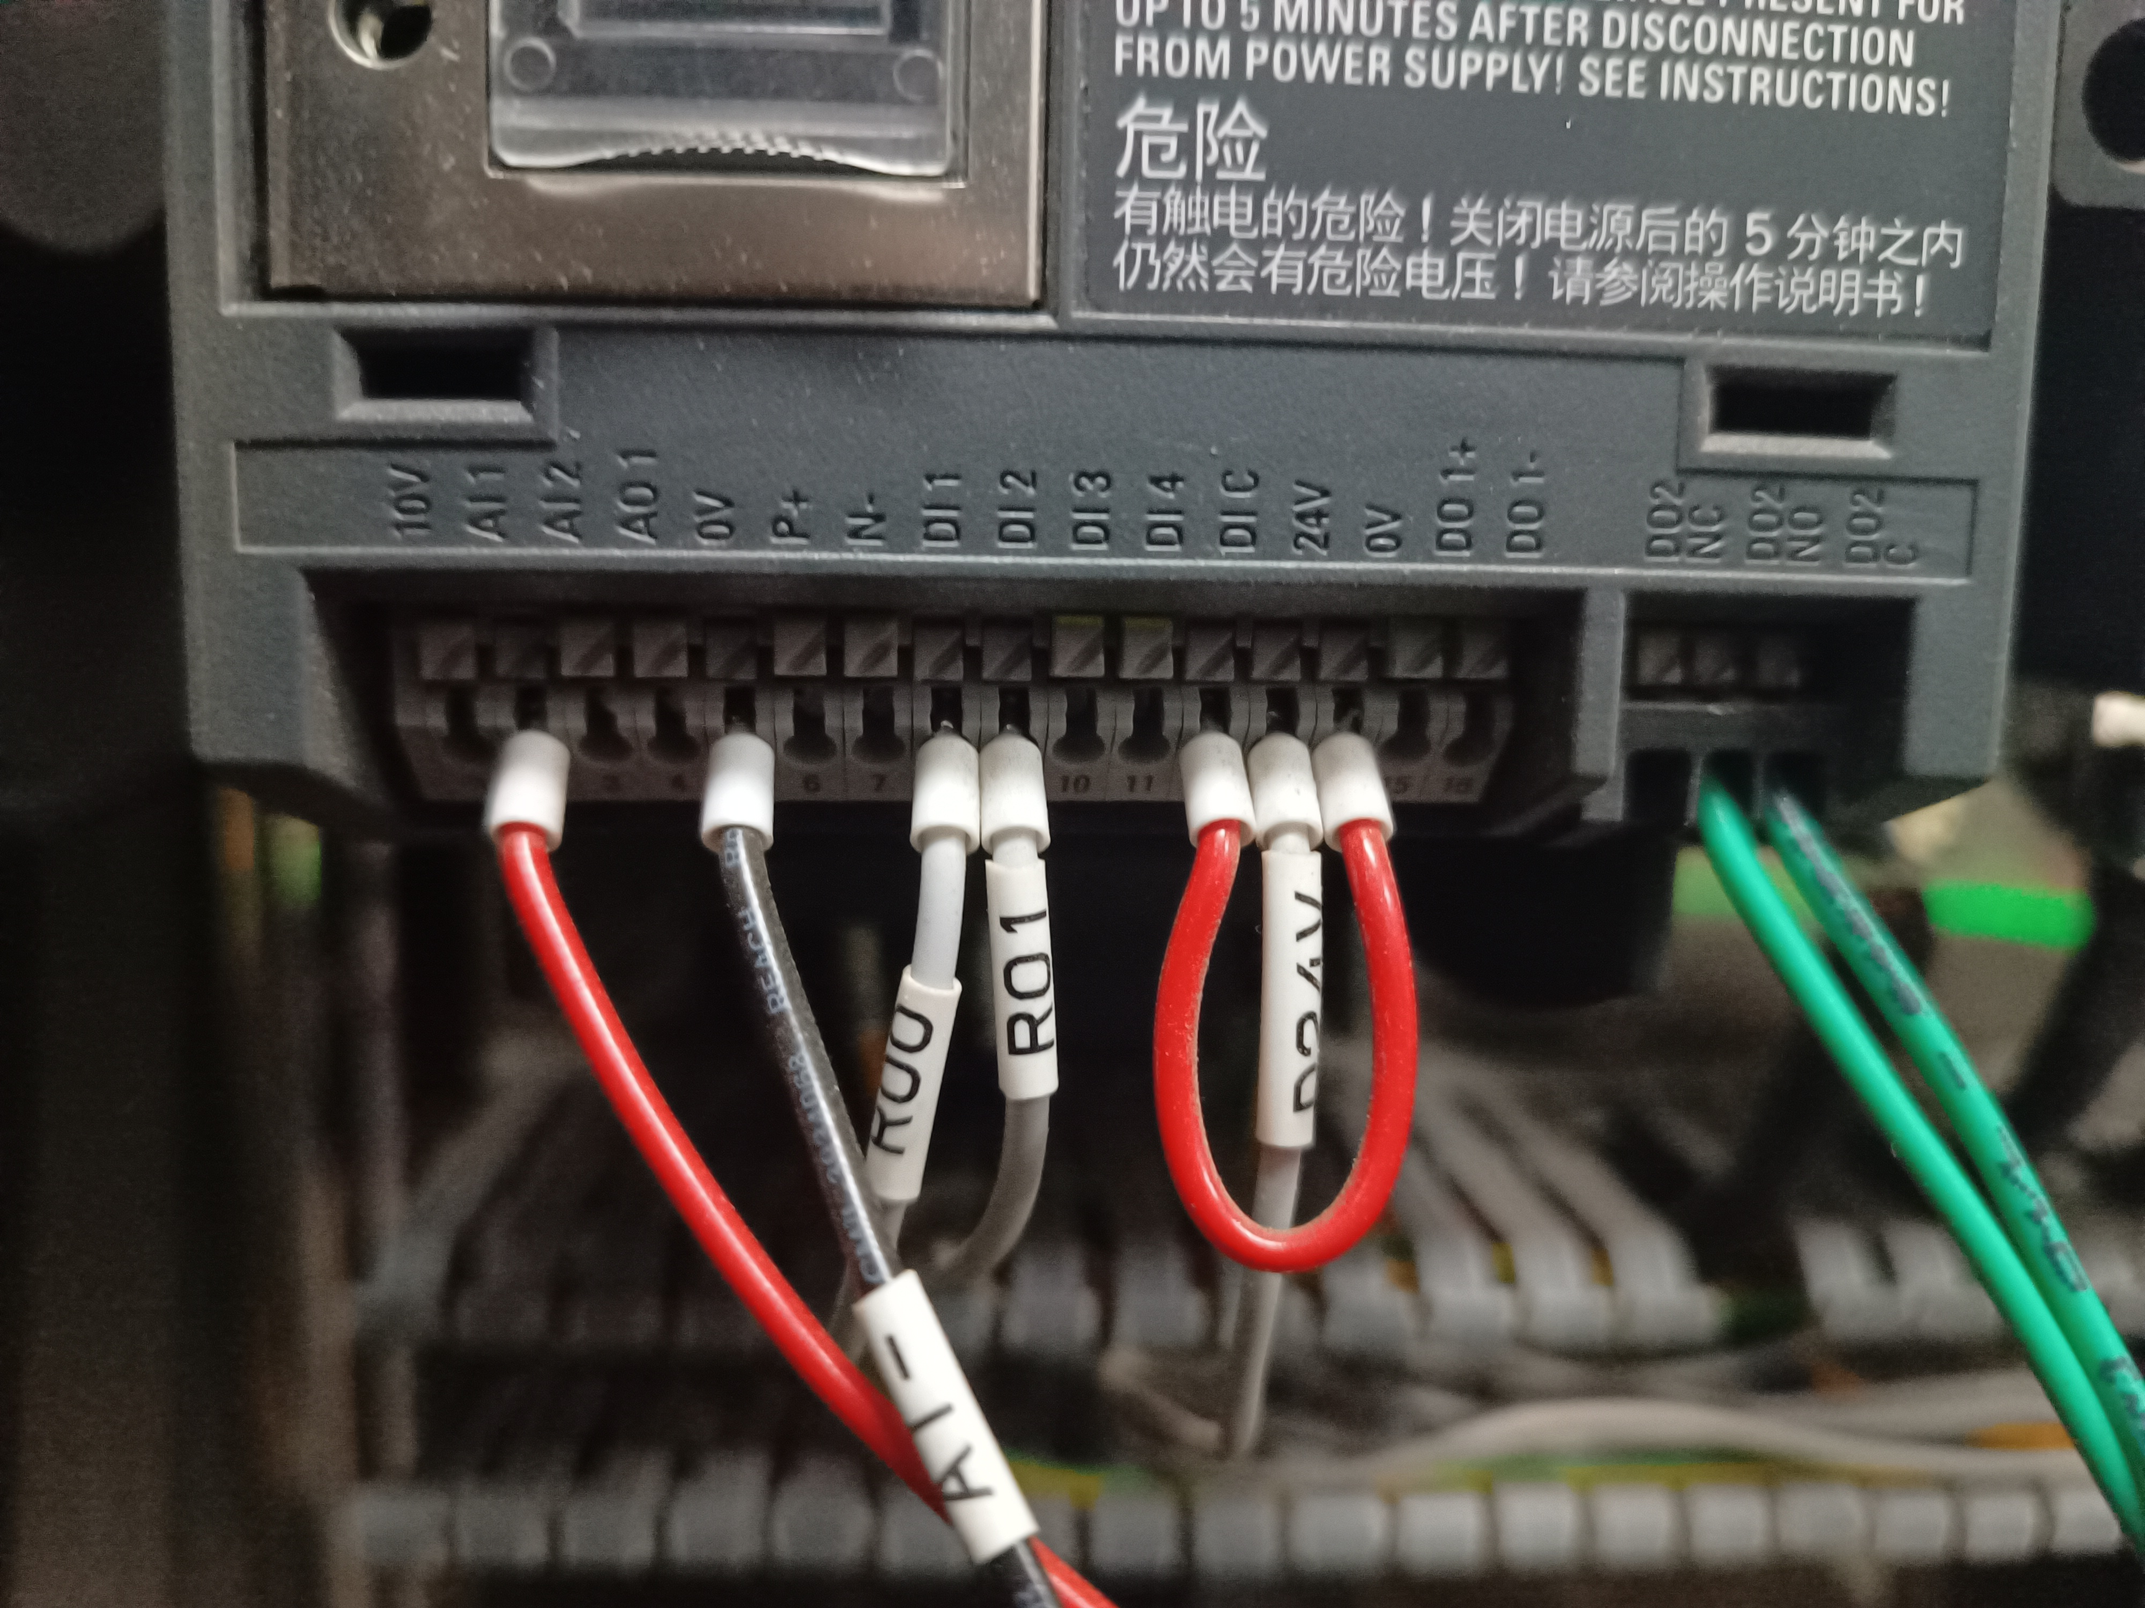

1. **Bluetooth Module**

* The HC-05 module facilitates Bluetooth communication between an Android tablet and MCU. The behaviours of the module are outlined below:
* If the red LED blinks continuously, it indicates that Bluetooth is not connected.
* If the LED blinks once every 4 seconds, it signifies that Bluetooth is successfully connected.

1. **Max6675 Thermocouple Module**

* K **-** Type Thermocouple is used for the Temperature measurement this module is Connected to the Mentioned RMC Socket.

1. **Flow Sensor**

* 45 mm Flow sensor is used for the Flow measurement it should be connected in the first 3 pin RMC socket.

1. **Charger Output**

* The First pin is the relay controlling pin this terminal is connected to the 8th relay in the relay bank

***Note: The relay is negative controlled so connect the terminals is negative port of the relay bank.***

1. **Output Controls**

This section is solely intended for outputs.

A voltage of 24V will be drawn from the two terminals indicated in the picture.

This voltage will be utilized to control the drain valve and the relay.

1. **Water Inlet valve**

The Water inlet output terminal is connected to the 7th relay in the relay bank

1. **Heater**

The Heater control output is connected to the 6th relay in the relay bank.

1. **Light**

The light control output is connected to the 5th relay in the relay bank.

1. **Wash pump**

The Wash pump control output is connected to the 4th relay in the relay bank.

1. **Drain valve**

The Drain valve control output is connected to the 3rd relay in the relay bank.

1. **Motor reverse**

The Motor Reverse control output is connected to the 2nd relay in the relay bank.

1. **Motor Forward**

The Motor Forward control output is connected to the 1st relay in the relay bank.

1. **Input section**

* First Pin will be used for the proximity sensor input
* Drain valves Grey colour wire is connect to the DV_open Terminal
* Drain Valves Pink Colour wire is connected to the DV_Close Terminal
* VFDs D02 (NO) Socket pin will be connected to the VFD Feedback.
* Connect the Drain valve and Proximity Sensors Ground in the GND terminal.

1. **Power Measurement Board Connector**

* The MCP3008s SPI wire will be connected with this socket. Socket 11 is shown in the Picture is the another point connector.
* 6 pin RMC socket is used Each pins direction is straight to the another one.

1. **Power Measurement Board Connector**

* No 10 socket is connected with this port

1. **3 phase Supply connector**

* This Board is used to Measure the Voltage and Current Consumption value.
* 3 phases, Phase terminals will be connected to this terminal

1. **CT coil Terminals**

* Three CT coils will be Connected to this Port